**LAB EXERCISE-5**

**SAP ID: 500069424**

**Aim: Install and Manage Maven Plugin using Eclipse**

Install Site Plugin and use “mvn site” command and goal for generating documents for Maven Project using Eclipse.

1.) Create a Maven Project in Eclipse.

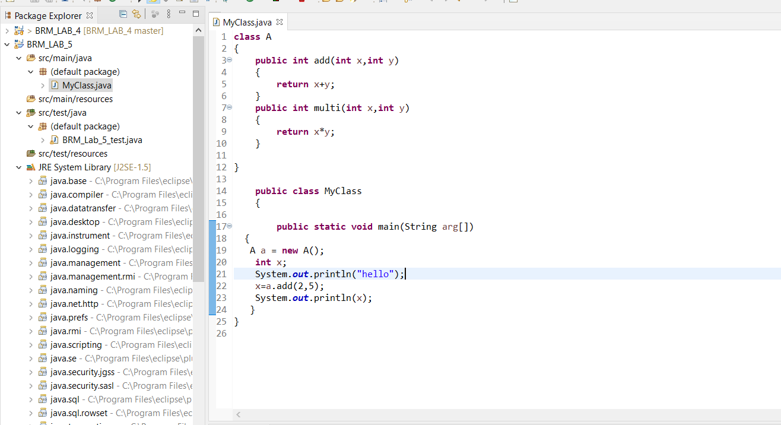

2.) Create JUnit test

Right click on project->new->other->search JUnit

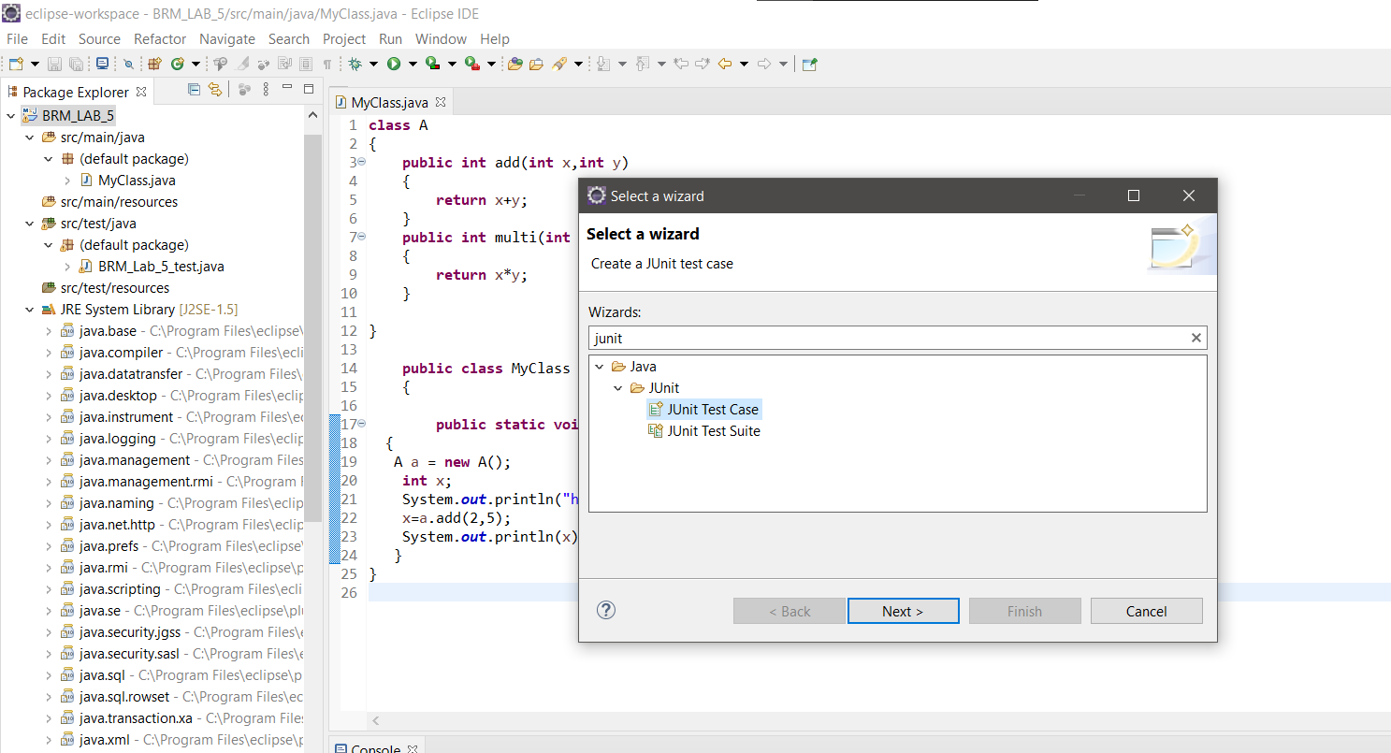

Select: JUnit Test Case

3.) add Maven Site Plugin in “*pom.xml”* file

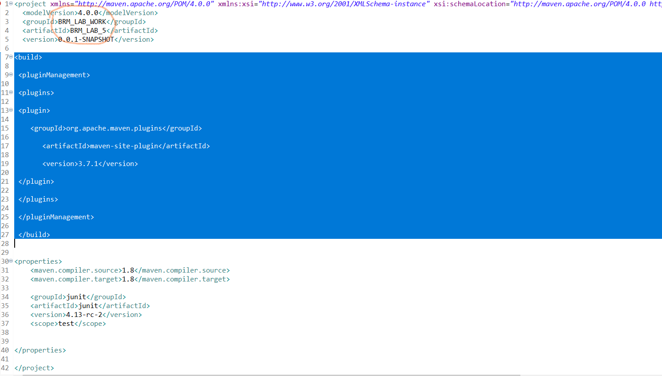

***Note:*** *through pom.xml file you can change the name of build artefact*

Without these plugins Maven goal “site” won’t work

4.) Now go to workspace directory of the Project:

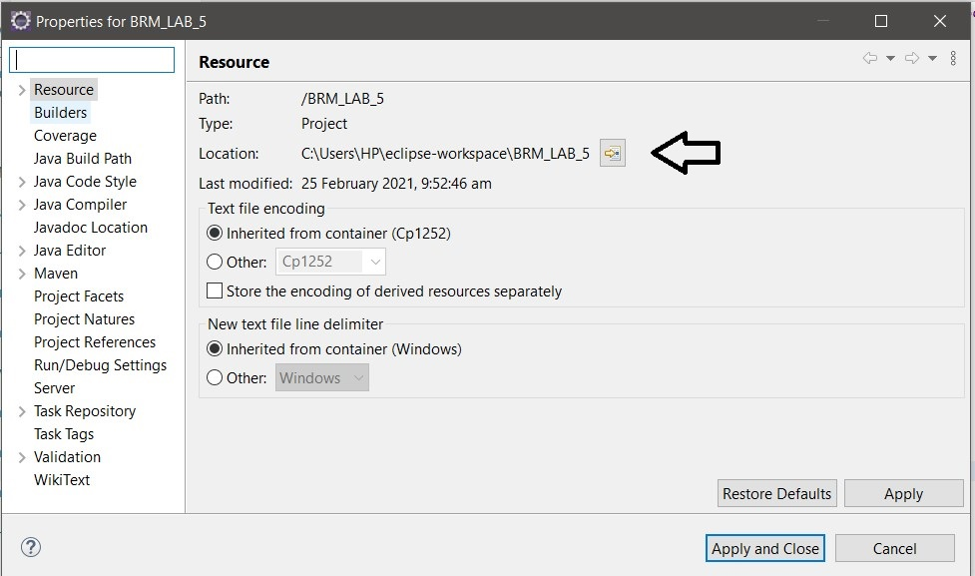

**And GoTo:** *User\eclipseworkspace\<Project_Name>\target\site*

5.) Open **index.html**



